**CUSTOMER ANALYSIS USING TABLEAU**

By

Mohit Mande(STB03-T0016)

Submitted to **Scifor Technologies**

in partial fulfilment of the requirements

for the final project during training as

a **Data Science Intern**



**Scifor Technologies**

No.13-14, 2nd floor, Kothnur Main Rd, opposite Corporation Bank,

JP Nagar 7th Phase, Bengaluru, Karnataka 560078

**TABLE OF CONTENTS**

* Declaration
* Acknowledgements
* Abstract
* Introduction
* Motivation
* Problem Statement
* Proposed Method
* Methodology
* Output & Results
* Conclusion
* Future Scope
* References

**DECLARATION**

I hereby declare that this submission is my own work and that, to the best of my knowledge and belief, it contains no material previously published or written by another person nor material which to a substantial extent has been accepted for the award of any other degree or diploma of the university or other institute of higher learning, except where due acknowledgment has been made in the text.

Name: Mohit Mande

Date: ………………

**ACKNOWLEDGMENT**

I would like to express my sincere gratitude and appreciation to all those who have contributed to the successful completion of this project. Their support, encouragement, and assistance have played a crucial role in making this endeavor possible. I would also express a special gratitude to my mentor Mrs. Urooj Khan for guiding me throughout my work while training.

**ABSTRACT**

This project, "Customer Analysis Using Tableau," is a focused exploration into extracting meaningful insights from a diverse customer dataset through the lens of Tableau's data visualization capabilities. By leveraging Tableau's powerful features, we aim to transform raw customer data into interactive and informative dashboards. The primary objectives include identifying distinct customer segments based on demographics, purchase patterns, and feedback, as well as revealing trends that can guide strategic decision-making in marketing and product development. Through meticulous data exploration, visualization design, and dynamic dashboards, this project aims to provide a comprehensive understanding of customer behavior and preferences.

The significance of this project lies in the pivotal role of understanding customer data for businesses. In an era where personalized customer experiences drive success, insights derived from Tableau dashboards can inform targeted marketing strategies, optimize resource allocation, and enhance overall customer satisfaction. The project's outcomes, including engaging visualizations and actionable insights, contribute to the growing importance of data-driven decision-making in today's competitive business landscape. This endeavor demonstrates the potential of Tableau as a transformative tool for customer analysis, emphasizing the practical applications of data visualization in informing strategic business decisions and fostering a customer-centric approach.

**INTRODUCTION**

In the dynamic landscape of modern business, understanding and responding to customer behavior is fundamental to success. The project titled "Customer Analysis Using Tableau" represents a strategic initiative aimed at unraveling the intricacies of customer interactions through the lens of data visualization. In today's data-driven era, where information is abundant and diverse, harnessing the power of tools like Tableau becomes imperative for businesses seeking actionable insights from their customer data.

This project embarks on a journey to explore a curated dataset encompassing a wealth of customer information, ranging from demographics and purchase history to valuable feedback. The central focus lies in leveraging Tableau's sophisticated analytics and visualization capabilities to transform raw data into comprehensible and interactive dashboards. By doing so, we aim to decode customer preferences, unveil patterns in purchasing behavior, and ultimately empower businesses with the knowledge required to make informed decisions.

**MOTIVATION**

In a world inundated with data, the ability to decipher meaningful insights has become a cornerstone of informed decision-making. This project is motivated by the desire to empower businesses with the tools and knowledge needed to understand their customers on a deeper level. In leveraging Tableau's robust capabilities for data visualization, we aim to transform intricate datasets into actionable insights, providing a strategic advantage for businesses navigating the complexities of today's competitive landscape. The motivation stems from the belief that unlocking the potential within customer data through Tableau can catalyze smarter strategies, foster innovation, and ultimately elevate the customer experience.

**PROBLEM STATEMENT**

Inefficient utilization of customer data hampers businesses' ability to make informed decisions. The absence of a systematic approach to analyze and visualize this data leaves organizations struggling to personalize strategies, optimize product offerings, and enhance overall customer satisfaction. This project aims to address this critical issue by leveraging Tableau to unlock actionable insights from customer data, providing businesses with the tools they need for strategic decision-making in a data-driven era.

**PROPOSED SYSTEM**

The proposed system entails the implementation of Tableau as a central tool for customer analysis. The system aims to create a dynamic and interactive environment where businesses can glean valuable insights from their customer data. Leveraging Tableau's robust features, the system will generate visually compelling dashboards that encapsulate key metrics, such as customer demographics, purchasing patterns, and feedback. The proposed system intends to streamline the process of extracting actionable insights, enabling businesses to make informed decisions, enhance marketing strategies, and optimize customer engagement.

**METHODOLOGY**

**Data Collection:**

Gather a comprehensive dataset containing diverse customer information, including demographics, purchase history, and feedback.

**Data Exploration:**

Conduct thorough exploratory data analysis to understand the structure and characteristics of the dataset.

**Preprocessing:**

Cleanse and preprocess the data to handle any inconsistencies, missing values, or outliers that may affect the analysis.

**Tableau Implementation:**

Utilize Tableau for developing interactive dashboards and visualizations.

Create visual representations of customer demographics, purchasing trends, and feedback analysis.

**Customer Segmentation:**

Identify distinct customer segments based on predefined criteria, such as demographics and purchasing behavior.

**Pattern Recognition:**

Employ Tableau's analytical capabilities to recognize patterns in customer behavior, preferences, and satisfaction.

**Insight Extraction:**

Extract actionable insights from the visualizations and dashboards, focusing on areas for strategic improvement and optimization.

**OUTPUT**

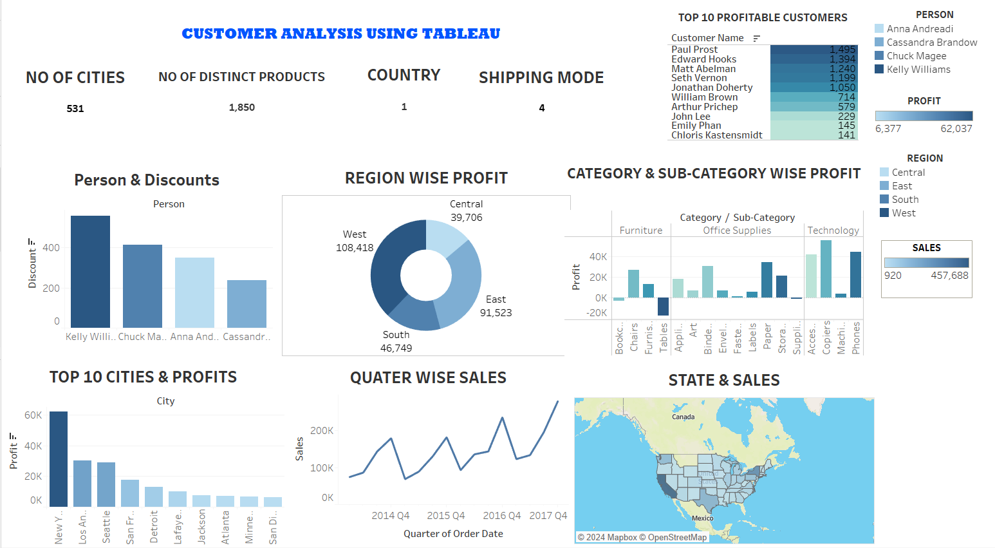

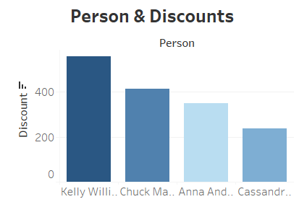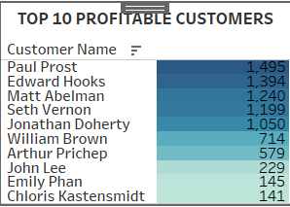

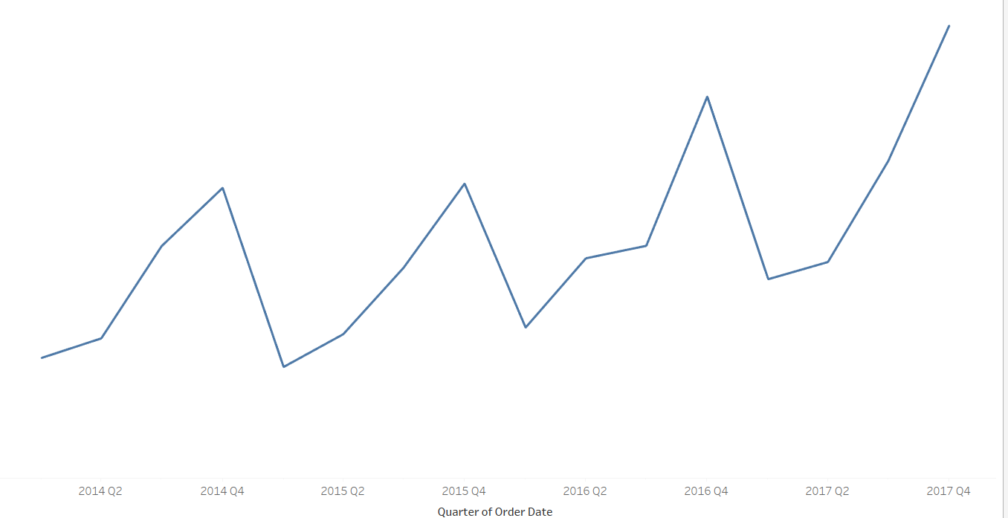

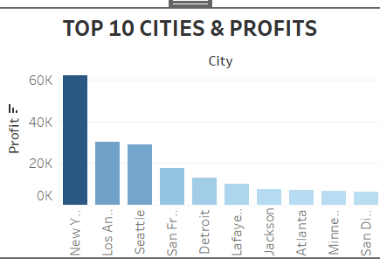

**CONCLUSION**

In concluding the "Customer Analysis Using Tableau" project, I have successfully demonstrated the power of data visualization in unraveling valuable insights from a diverse customer dataset. Through the implementation of Tableau, we've transformed raw data into interactive and informative dashboards, providing a comprehensive understanding of customer behavior, preferences, and trends. The outcomes of this project hold significant implications for strategic decision-making in marketing, product development, and overall customer engagement.

**FUTURE SCOPE**

The project lays the groundwork for several avenues of future exploration and enhancement. Some potential areas for future development include:

**Advanced Analytics Integration:**

Incorporating advanced analytics and machine learning models within Tableau for more sophisticated customer predictions and trend analysis.

**Real-time Data Integration:**

Expanding the project to incorporate real-time customer data, allowing businesses to respond swiftly to evolving trends and customer behavior.

**Integration with Customer Relationship Management (CRM) Systems:**

Exploring seamless integration with CRM systems to enhance customer relationship management and streamline data flow.

**Enhanced Interactivity:**

Augmenting the interactivity of Tableau dashboards to enable end-users to explore and analyze data in more dynamic ways.

**Benchmarking and Comparative Analysis:**

Implementing features for benchmarking and comparative analysis to assess a business's performance against industry standards.

**REFERENCES**

* J. Heer and B. Shneiderman, "Interactive Dynamics for Visual Analysis," Communications of the ACM, 2012.
* C. Stolte, D. Tang, and P. Hanrahan, "Polaris: A System for Query, Analysis, and Visualization of Multidimensional Relational Databases," IEEE Transactions on Visualization and Computer Graphics, 2002.